Openshift Migration Plan

Steps Involved in Migration

1. Migration Prerequisites
2. Bring up the Target Cluster (in Openshift 4 version)
3. Configuration of Object Store (Replication Repository)
4. Installing CAM Tool on Source Cluster
5. Installing CAM Tool on Target Cluster
6. Configuration of the Cross Origin resource Sharing
7. Application Migration using CAM web console
8. Control Plane migration assistant to migrate the control plane tool.

Steps Involved in Migration Process (Higher Level Understanding)

Step 1: Install or Bring up the Openshift 4 cluster

Step 2: Openshift 4 Cluster Configuration

Step 3: Plan to manage the application data being migrated

Step 4: Migration Plan execution

Step 5: Configure DNS and Load Balancer to the Newly created Openshift 4 Cluster

1.Migration Prerequisites:

Step 1: You must have the podman installed.

Step 2: Must have cluster admin privileges to all the clusters

Step 3: A repository accessible to source and target clusters

Step 4: If the source cluster applications is using images from the openshift namespace, all the versions present in the source cluster should be there in the target cluster.

You can find the list of image stream tags removed in the target cluster from the link below

To ease our tasks and also to facilitate faster and convenient migration. We use two tools

* Cluster Application Migration Tool.
* Control Plane application Migration Tool.

2. Understanding Cluster Application Migration Tool ?

We use this to migrate the kubernetes resources, persistent volumes, all the internal container images from the source to target cluster.

THis is achieved using CAM web console or the kubernetes API

Let’s use the web console to migrate the openshift cluster

Step 1 : Install the CAM operator

Step 2 : To enable the communication between the cluster and API, we have to enable cross origin resource sharing.

Step 3: Create a object store, this object store acts as the intermediate medium data exchange/migration between the source and the target cluster

Step 4: Add the source cluster to CAM console.

Step 5: Add the replication repository or object store to CAM console.

Step 6: ***Create*** the migration plan with any one of the options a) copy b) move

Step 7: ***Execute*** the migration plan with any one of the options a) stage b) migrate.

In general, Cluster migration tool copies the values from source cluster to the replication repository and from replication repository to the target cluster.

3. Methods to configure the object store

We can use any storage providers, like Amazon, Azure, Google Cloud.

There are two types of copy methods: ***file system copy and snapshot copy.*** And CAM operators support both of them.

***What is File system copy method ?***

Copy the files from source cluster -> replication repository -> target cluster

***What is the Snapshot file system copy method ?***

The CAM tool copies a snapshot of the source cluster’s data to a cloud provider’s object storage, configured as a replication repository. The data is restored on the target cluster.

Let's use the AWS object store as the replication repository

// Steps to configure AWS as the replication repository.

4. Deploying Cluster application migration tool in the Openshift 3 source cluster

Step 1*:**$ sudo podman login registry.redhat.io*

Step 2: Download the operator which is a yaml file

*sudo podman cp $(sudo podman create registry.redhat.io/rhcam-1-1/openshift-migration-rhel7-operator:v1.1):/operator.yml ./*

Step 3: Download the controller which is a yaml file

*sudo podman cp $(sudo podman create registry.redhat.io/rhcam-1-1/openshift-migration-rhel7-operator:v1.1 ):/controller-3.yml ./*

Step 4: Create a cam operator Custom resource object

*Oc create -f operator.yml*

Step 5: Create a migration controller object

Oc create -f controller.yml

Step 6 : Check if velero or rustic pods are running.

5. Installing cam operator on Target cluster

Step 1: Administrator -> Namespaces

Step 2: Create a Namespace names openshift migration

Step 3: Operators -> Operators Hub select the CAM operator and install

Step 4: Create Operator subscription -> Openshift migration -> Automatic or manual subscribe

Step 5: Check if the operator is successfully installed

Step 6: Under provided APIs -> click more -> Create New -> Migration Controller -> Create

Step 7: Check if velero and rustic pods are running

6. Configuring Cross origin resource sharing on openshift

You must configure cross-origin resource sharing on an OpenShift Container Platform 3 source cluster to enable communication between the source cluster’s API server and the CAM tool.

Step 1: Login to cluster in which CAM Tool is enabled

Step 2: CORS configuration

*$ oc get -n openshift-migration route/migration -o go-template='(?i)//{{ .spec.host }}(:|\z){{ println }}' | sed 's,\.,\\.,g'*

Step 3: Login to the Openshift container platform 3 source cluster and add the configuration value to the corsAllowedOrigins in the /etc/origin/master/master-config.yaml

Step 4: corsAllowedOrigins:

- (?i)//migration-openshift-migration\.apps\.cluster\.com(:|\z)

- (?i)//openshift\.default\.svc(:|\z)

- (?i)//kubernetes\.default(:|\z)

Step 5: Restart the API and controller manager to make sure that the changes are reflected properly.

Step 6: Verify Configurations.

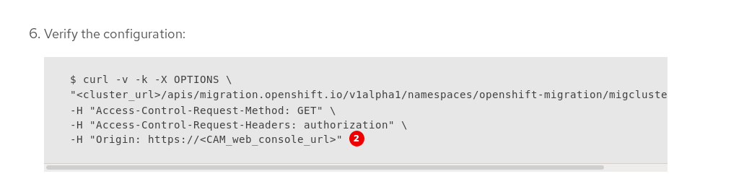

7. Application Migration using CAM web console

8. Migrating the control plane setting with Control Plane Migration Assistant.

Why are we using a Control Plane migration assistant ?

Control Plane migration assistant assists you in migration of control Plane from Source to the Target Cluster.

This tool processes the configuration files and generates Custom Resource (CR) manifest files, which are then confused by the Openshift manifest files.

Some of the Configuration files are

Master Configuration **/etc/origin/master/master-config.yaml**

CRIO Configuration **/etc/crio/crio.conf**

ETCD configuration /etc/etcd/etcd.conf

Image Registers file **/etc/containers/registries.conf**

Some other dependent files are

1. Secrets
2. Config Maps
3. Password files

Custom Resource Manifests

Control plane migration assistant generates several Custom Resource manifests

API Server CA certificate

Name of the manifest file

* *100_CPMA-cluster-config-APISecret.yaml*
* *CRI-O: 100_CPMA-crio-config.yaml*
* *Cluster resource quota: 100_CPMA-cluster-quota-resource-x.yaml*
* *Project resource quota: 100_CPMA-resource-quota-x.yaml*
* *Portable image registry (/etc/registries/registries.conf) and portable image policy (etc/origin/master/master-config.yam): 100_CPMA-cluster-config-image.yaml*
* *OAuth providers: 100_CPMA-cluster-config-oauth.yaml*
* *Project configuration: 100_CPMA-cluster-config-project.yaml*
* *Scheduler: 100_CPMA-cluster-config-scheduler.yaml*
* *SDN: 100_CPMA-cluster-config-sdn.yaml*

Install the control plane assistant tool

Using the control plane assistant tool

Step 1) login to Openshift platform 3

Step 2) Run the CPMA, Make sure to answer every prompt.

cpma --manifests=false

|  |
| --- |
| **--manifests=false**: Without generating CR manifests |
|  |

CPMA create the following files and directory in the current directory (if directory is not provided)

* **cpma.yaml** file: Configuration options that you provided when you ran the CPMA
* **master1.example.com/**: Configuration files from the master node
* **report.json**: JSON-encoded report
* **report.html**: HTML-encoded report

Step 3) Open the report.html

Step 4.) Run the command in the openshift cluster 4

oc apply -f 100_CPMA-cluster-config-secret-htpasswd-secret.yaml